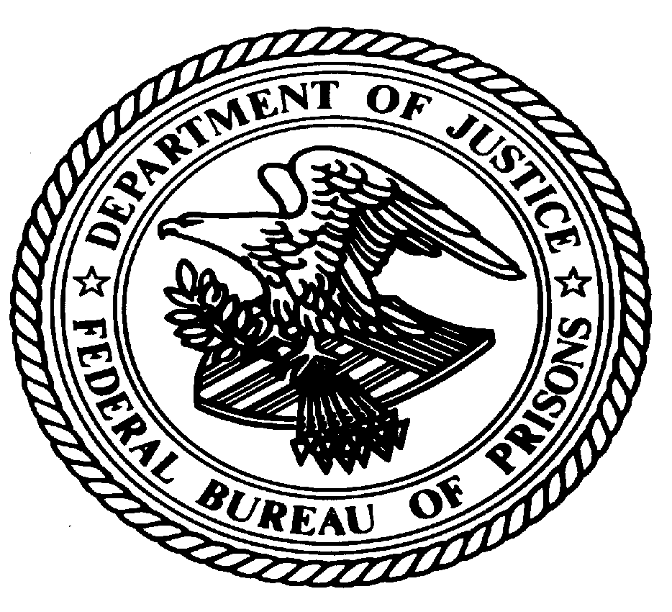
U.S. Department of Justice
Federal Bureau of Prisons
Federal Medical Center Carswell
Fort Worth, TX 76127
Office of the Warden

((Date))

MEMORANDUM FOR T. RULE, WARDEN, FMC CARSWELL

FROM: Seth Thomas, Human Resource Specialist

SUBJECT: OIA Check – Prior Employee

To maintain compliance with Program Statement 3000.04, Human Resources Management Manual, concerning Reinstatement of Former Bureau Employees, I am requesting an OIA check be conducted in reference to the below possible reinstatement prior to her appointment:

Name: Doe, Jane (input field)
SSN: 555-55-5555(input field)
DOB: 12/01/1995 (input field)
Date of Employment: 01/01/2024 – 10/10/2024 or Present(input field)

_(checkbox field)_________ Cleared/Approved for Appointment

_(checkbox field)_________ Not Cleared/Disapproved

__________________________ _______________
T. Rule, Warden Date

